**IPT101**

Economic Structure

Members (indicate full name – designated role):

1. Adriano, Jessica Raye – Sound Engineer

2. Hidalgo, Maika Jasmine – Artist

3. Jacinto, Alexis Rovic John – Programmer

4. Marcos, Dannah Lei – Game Designer

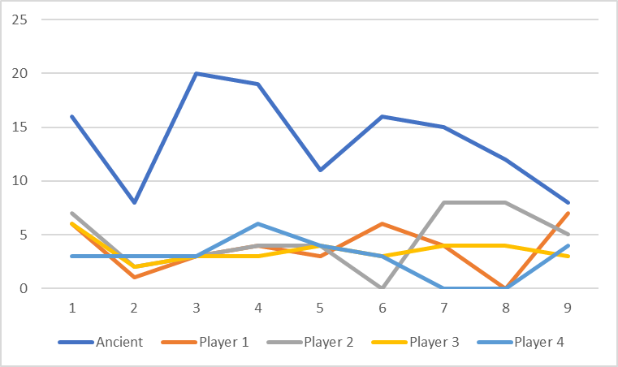

Figure 1.1. Dice Count.

“**Against The Ruins**” operates primarily on rolling lots of dice to progress, and playing cards to modify the number of dice, flat addition to scores, subtraction, and other unrelated effects. The Figure 1.1 shows a varying number of dice for the Ancient, but still scoring high, while the other players are hovering way below. Removing the Ancient from the graph (in Figure 1.2), which will be done in the other graphs as well, reveals a somewhat consistent number of dice at the beginning, which immediately becomes chaotic due to later cards having stronger effects. This may be interpreted as a horizontal equilibrium for all players; with the Ancient’s total dice count zoning at around 12 to 14, and the Archaeologist’s dice counts hovering between 3 and 5.

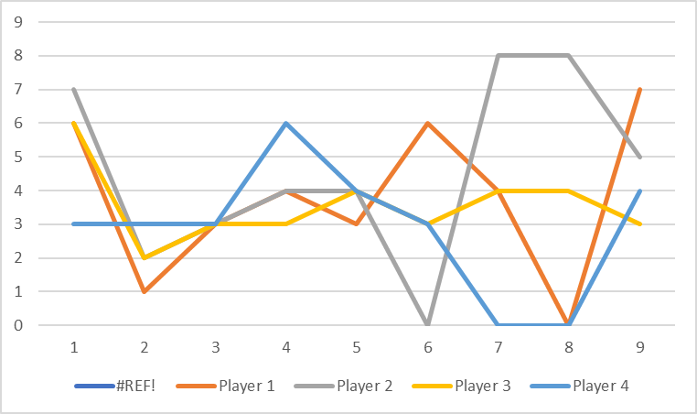

Figure 1.2. Dice Count w/o Ancient’s Data.

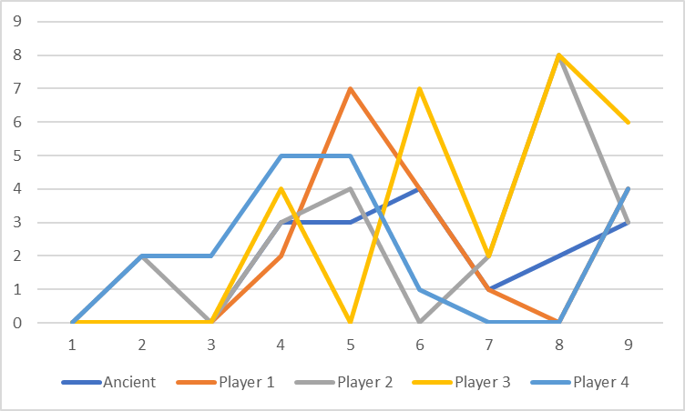

Figure 2.1. Trinkets Spent.

Figure 2.1 shows the Trinket spending of every player. At the start of the game, all players are either holding low-cost cards and/or conservative in their play, which evolves into a pattern of either spending high and earning nothing, or being frugal and earning a bit more. Figure 2.2, without the Ancient, does not show any difference due to the Ancient spending at roughly the same rate as the Archaeologists. This may be interpreted as a loose incremental equilibrium, as players are forced to spend more during the later parts of the game.

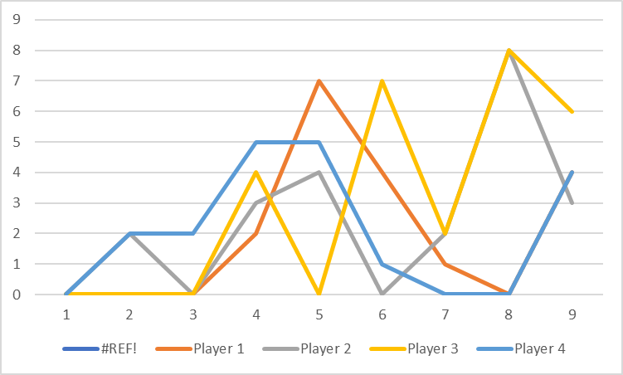

Figure 2.2. Trinkets Spent w/o Ancient’s Data.

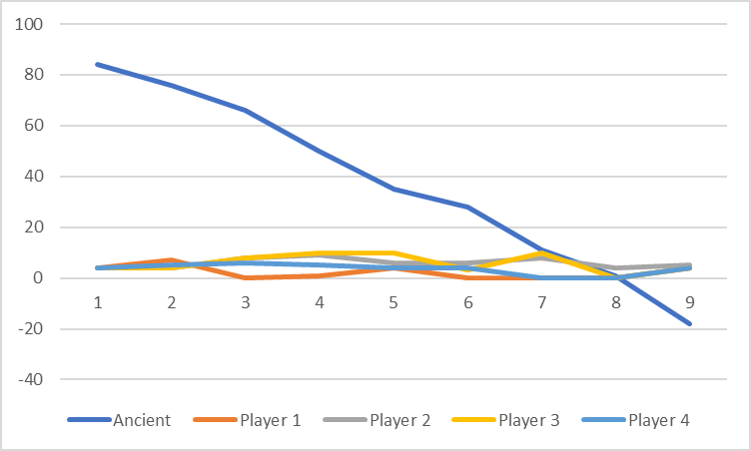

Figure 3.1. Total Trinkets.

Figure 3.1 shows the total number of trinkets for each player, which the Ancient massively dwarfs due to having 100 at the start. A mistake in the data collection shows that the Ancient gets -18 by round 9, which is impossible. It may be surmised that the Archaeologists, or the Expedition, have defeated the Ancient in a previous version simply by reducing the Trinket Pool to 0. Figure 3.2 shows a closer look at other players’ Total Trinkets, which fluctuates quite a lot, but eventually decreases towards the end. This is expected, as higher cost cards force players to dip into their savings in order to keep playing. These graphs indicate a horizontal equilibrium: for the Archaeologists, it is intended that their spending averages between 2 and 5 Trinkets per round, and for the Ancient, while a decline is seen, the decline is consistent, which is expected with how the game is supposed to be played.

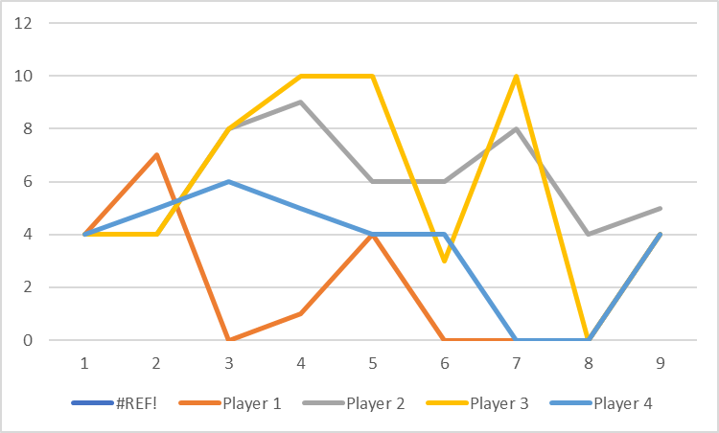

Figure 3.2. Total Trinkets w/o Ancient’s Data.

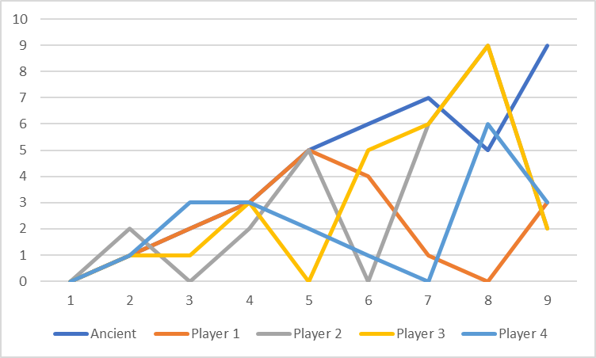

Figure 4. Alert and Risk Values

One of the major mechanics of the game is the Alert and Risk Mechanic, forcing all players to make suboptimal moves with the restrictions, both soft and hard, on the cards they hold. Figure 4 shows the general trend of both the Alert and Risk Values. The Ancient’s Alert Value has a general trend to increase, which is similar with the Risk Values of the Expedition, which, while varying, is seen a consistent upward trend. This indicates a rising equilibrium, since the Ancient’s Alert Value is increasing continuously